COMM647 Assignment – Manu Ria

SEO stands for “search engine optimization.” It is the process of getting traffic from the “free,” “organic,” “editorial” or “natural” search results on search engines. SEO stands for “search engine optimization.” It is the process of getting traffic from the “free,” “organic,” “editorial” or “natural” search results on search engines.

1. The search engine I usually use is **google, YouTube and Yahoo .** A **web search engine** is a software system that is designed to search for information on the [World Wide Web](https://en.wikipedia.org/wiki/World_Wide_Web). The search results are generally presented in a line of results often referred to as [search engine results pages](https://en.wikipedia.org/wiki/Search_engine_results_page) (SERPs). The information may be a mix of [web pages](https://en.wikipedia.org/wiki/Web_page), images, and other types of files. Some search engines also [mine data](https://en.wikipedia.org/wiki/Data_mining)available in [databases](https://en.wikipedia.org/wiki/Database) or [open directories](https://en.wikipedia.org/wiki/Web_directory). Unlike [web directories](https://en.wikipedia.org/wiki/Web_directories), which are maintained only by human editors, search engines also maintain [real-time](https://en.wikipedia.org/wiki/Real-time_computing) information by running an [algorithm](https://en.wikipedia.org/wiki/Algorithm) on a [web crawler](https://en.wikipedia.org/wiki/Web_crawler). **(**From Wikipedia**) In the past I used bing and Aol but I found that Google produces easier and cleaner results (not clotted with ads). I do lots of Research and I prefer Google and YouTube (for videos), but since I use yahoo mainly for emails, when I am on yahoo page, I may use their search engine too. I do not trusts google or yahoo, as they get paid to promote certain businesses, so I usually skip the top suggestions and go right to the end of page or 2nd or 3rd page. On YouTube however I narrow the search either based on time (earlier first or this week) when searching for news or sports related videos. And on tutorial videos, most viewed in this year.**
2. As far as doing search on mobile devices **I use them for finding address and related maps**, but even then I prefer to search in google on my laptop before I get in my car.
3. **When a search engine returns its search results, it gives you two types: organic and paid. Organic search results are the Web page listings that most closely match the user’s search query based on relevance listings. Paid results are basically advertisements**

**The benefit of organic listing is that it is free, the drawback is that my page is not on the top, since I am cheap and don’t want to pay much for advertisment.** According to [ComScore](http://www.comscore.com/Insights/Market-Rankings/comScore-Releases-April-2014-US-Search-Engine-Rankings), search engine users conducted 18.6 billion explicit core searches in April 2014. That number excluded searches without specific intent to interact with the search results. The search engine result pages (SERPs) likely provided a mix of both organic and paid rankings.

Both organic and paid (PPC) have distinct advantages and drawbacks. Knowing them will allow you to get the best return for your search marketing dollars. As you will see, combining them will often result in a better click through rate (CTR).

## **My listing may not appear high on the list if my SEO is poorly done. Organic Search Benefits**

* **Trust and credibility:** With high search engine rankings comes a perception of credibility on the part of searchers. High search rankings imply industry authority and leadership. This perception translates into more trust and a greater likelihood to click through to the site.
* **Evergreen:**If the content that ranks high is evergreen, then the rankings will also have a more evergreen presence. The specific listing may rank high long after the content was created.
* **Ranking**: Once you get high rankings, it’s easier to keep those rankings. You get authority status and build the trust of users and search engines.
* **Click through rates**: For “top of funnel” search terms, I.e., don’t show immediate purchase intent, the click through rates are better for organic search results. That’s very important for businesses that have a longer buying cycle.
* **Inbound marketing:**An organic search strategy requires marketers to develop the content assets to achieve it. This is important for higher involvement purchases. Users interact with content as they move down the purchase funnel.

## **Organic Search Drawbacks**

* **Time:**Depending on the competitiveness of the keywords involved, it may take months or years to get high rankings. Can you wait that long?
* **Resources:** Getting high rankings requires both creating content and using SEO tactics to achieve it. That can be difficult, frustrating and time consuming. Either internal staff or external contractors are needed for both these functions.

## **paid listings are expensive, but yield faster results. Paid Ads (PPC) Benefits**

* **Time**: Unlike organic search rankings that can take months or years, paid results are placed at the top of rankings as soon as you pay for ad placement.
* **Targeting**: PPC campaigns can be tailored to reach specific audiences. Examples of segmentation include geo-targeting, income, age, educational level, marital status, industry, etc.
* **Click through rates**: Searches using terms that denote high purchase intent such as product or brand-specific keywords will get more clicks than organic results. The advantage of paid search can clearly be seen in the Internet retailers [MarketLive Performance Index](http://marketing.marketlive.com/acton/form/4039/0097:d-0001/0/index.htm?id=0097&utm_medium=email&utm_source=Act-On+Software&utm_content=email&utm_campaign=Free%20Report%3A%20The%20MarketLive%20%27013%20Recap-%20Revenue%20Growth%20Eclipses%20Forecasts&utm_t) data. For the year 2013 as a whole, PPC accounted for 36.5% of search traffic but an outsized 47.9% of revenue from search.

## **Paid Ads (PPC) Drawbacks**

* **Cost:**The more competitive the keyword, the more the bid price is for each click on the displayed ad. Paid search requires a level of expertise to manage these campaigns. Otherwise a lot of money will be spent to attract unqualified traffic.
* **Momentary**: The ads disappear as soon as you stop paying for them.
* **Distrust**: Consumers don’t always trust paid ads and often avoid them. They place more trust in organic rankings.
* **Click through rate:**Except for high purchase intent searches, users will click on paid search listings at a lower rate than organic search listings. Organic listings have more credibility with search engine users. In one UK study, published by [Econsultancy](https://econsultancy.com/blog/10586-ppc-accounts-for-just-6-of-total-search-clicks-infographic#i.r2qa7yt16dmbwj), only 6% of clicks were the result of paid listings. In another [study](http://www.statista.com/statistics/280327/ratio-of-paid-to-organic-search-clicks-in-the-united-kingdom-uk/), it was 10%. The important thing to remember is that click through rate varies by purchase intent. Organic rankings will get more click through rates for “top of funnel” keyword search queries.

**So For now I go with Organic listing.**

1. **The keywords I use are “tutorial”, “how to make”, “what ‘it’ is” “what ‘it’means” “where ‘it’ is” “Iran” “news” “gold rio”.**

**Keyword: tutorial (Organic)**

### [Tutorial - Wikipedia, the free encyclopedia](https://www.google.com/url?sa=t&rct=j&q=&esrc=s&source=web&cd=2&cad=rja&uact=8&ved=0ahUKEwj9jYbU19DOAhUM4mMKHTaHAGYQFggwMAE&url=https%3A%2F%2Fen.wikipedia.org%2Fwiki%2FTutorial&usg=AFQjCNFUJCPkiFm76fYhsHG20VLhgAW8vA&bvm=bv.129759880,d.cGc)

### [The Java™ Tutorials - Oracle Help Center](https://docs.oracle.com/javase/tutorial/)

### [HTML Tutorial - W3Schools](http://www.w3schools.com/html/)

**Keyword: how to make healthy food (Organic)**

### [Healthy Meals, Foods and Recipes & Tips : Food Network](https://www.google.com/url?sa=t&rct=j&q=&esrc=s&source=web&cd=1&cad=rja&uact=8&ved=0ahUKEwir-vSY2NDOAhUQxWMKHaykAH0QFghCMAA&url=http%3A%2F%2Fwww.foodnetwork.com%2Fhealthy%2Fpackages%2Fhealthy-every-week.html&usg=AFQjCNEbR2-QTsx_h9SlyqQYztJPfI_bTw)

### [52 Healthy Meals in 12 Minutes or Less | Greatist](http://greatist.com/health/52-healthy-meals-12-minutes-or-less)

### [How to Cook Healthy Food! 10 Breakfast Ideas, Lunch Ideas & Snacks ...](https://www.youtube.com/watch?v=F6ehyV7kqv8)

**Keyword: what js is (Organic)**

### [JavaScript Introduction - W3Schools](https://www.google.com/url?sa=t&rct=j&q=&esrc=s&source=web&cd=3&cad=rja&uact=8&ved=0ahUKEwiNnJLI2NDOAhVI3GMKHfzVD98QFggnMAI&url=http%3A%2F%2Fwww.w3schools.com%2Fjs%2Fjs_intro.asp&usg=AFQjCNFHrenOghz6D9AIs3snllnppuWfYg)

### [What does JS mean? - JS Definition - Meaning of JS - InternetSlang.com](http://www.internetslang.com/JS-meaning-definition.asp)

### [JavaScript - Wikipedia, the free encyclopedia](https://en.wikipedia.org/wiki/JavaScript)

**Keyword: what concubine means (Organic)**

### [Concubine | Define Concubine at Dictionary.com](https://www.google.com/url?sa=t&rct=j&q=&esrc=s&source=web&cd=2&cad=rja&uact=8&ved=0ahUKEwimptL_2NDOAhUQzmMKHa_gCqgQFggwMAE&url=http%3A%2F%2Fwww.dictionary.com%2Fbrowse%2Fconcubine&usg=AFQjCNH07naMZxfWiRg7UkDCJv6WgkrYdg&bvm=bv.129759880,d.cGc)

### [Concubine | Definition of Concubine by Merriam-Webster](http://www.merriam-webster.com/dictionary/concubine)

### [Concubine. - Definition and Meaning, Bible Dictionary - Bible study](http://www.biblestudytools.com/dictionary/concubine/)

**Keyword: where Ethiopia is (Organic)**

### [Where is Ethiopia? / Where is Ethiopia Located in The World ...](https://www.google.com/url?sa=t&rct=j&q=&esrc=s&source=web&cd=3&cad=rja&uact=8&ved=0ahUKEwjC4_O22dDOAhUIwmMKHfTGB0YQFggkMAI&url=http%3A%2F%2Fwww.worldatlas.com%2Faf%2Fet%2Fwhere-is-ethiopia.html&usg=AFQjCNEeDAOElW-4_CyDTb_PctNOdi4seA&bvm=bv.129759880,d.cGc)

### [Ethiopia - Wikipedia, the free encyclopedia](https://en.wikipedia.org/wiki/Ethiopia)

### [Where is Ethiopia? Location of Ethiopia - World Map](http://www.mapsofworld.com/ethiopia/ethiopia-location-map.html)

**The characteristics this website share: They all informational.**

**The different search engines do not produce same results.**

**Keyword: obama ransom to iran (Organic)**

**In Google:**

### [Iran ransom humiliates Obama - Washington Times](https://www.google.com/url?sa=t&rct=j&q=&esrc=s&source=web&cd=4&cad=rja&uact=8&ved=0ahUKEwiLqoSQqtHOAhUPzWMKHawJAOIQFgglMAM&url=http%3A%2F%2Fwww.washingtontimes.com%2Fnews%2F2016%2Faug%2F18%2Firan-ransom-humiliates-obama%2F&usg=AFQjCNGSJr21dlrozjQjKLCGIKy-CjYvTA&sig2=X70BD1ipqC-KsufXq8xc0A&bvm=bv.129759880,d.cGc)

### [Obama admin seeks to explain perceived ransom in Iran case ...](http://www.cnn.com/2016/08/19/politics/us-iran-prisoners-400-million-leverage/)

### [Obama's $400M Cash Payment to Iran Was a Ransom | National](http://www.nationalreview.com/corner/439155/obamas-400m-cash-payment-iran-was-ransom)

**In Bing:**

## [**Obama on Iran payment: 'We do not pay ransom ...**](http://www.cnn.com/2016/08/04/politics/iran-400-million-kerry-rejects-ransom/index.html)

## [**U.S. Concedes $400 Million Payment to Iran-Ransom**](http://www.nytimes.com/2016/08/19/world/middleeast/iran-us-cash-payment-prisoners.html)

## [**Obama’s ridiculous refusal to call that $400 million Iran ...**](http://nypost.com/2016/08/18/obama-ridiculous-refusal-to-call-that-400-million-iran-payment-what-it-is-ransom/)

**In yahoo:**

[Obama on Iran payment: 'We do not pay ransom' - cnn.com](http://www.cnn.com/2016/08/04/politics/iran-400-million-kerry-rejects-ransom/index.html)

[US says $400M to Iran was contingent on release of prisoners](http://www.foxnews.com/politics/2016/08/18/us-says-400m-to-iran-was-contingent-on-release-prisoners.html)

[$400 Million to Iran Was Not a Ransom, Obama Says - The New ...](http://www.nytimes.com/2016/08/05/world/middleeast/400-million-to-iran-was-not-a-ransom-obama-says.html)

**5- Google Keyword Planner is a paid service, so I searched to find a free Keyword Planner, First google suggestion was** [**http://keywordtool.io/pro**](http://keywordtool.io/pro) **which also is not free, when you try to find the real info, it hides the relevant information and suggest to upgrade to the paid pro version to see the hidden values.**

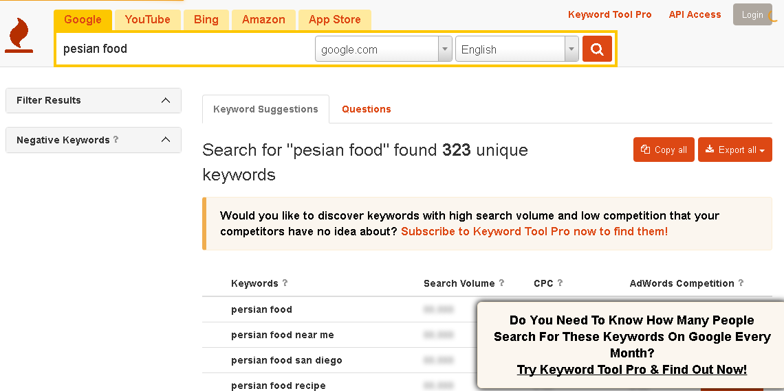

**Then I tried the second free suggestion, it also blured the page to force you to upgrade to a paid version.**

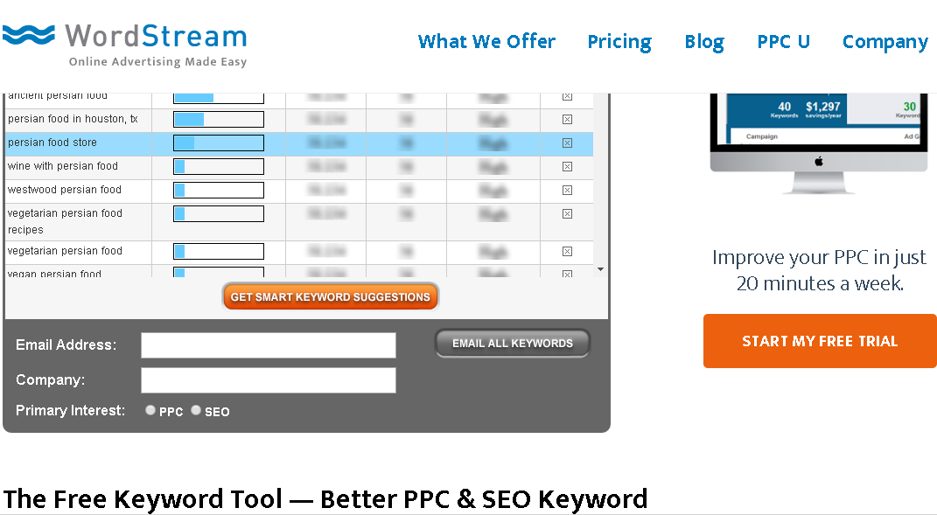

**So I went back to Google version and… checked for these keywords:**

**Persian restaurant, pizza, pasta, persian food, kabab, Persian cousin, dinner, lunch, soup, cake, vegeterian food**

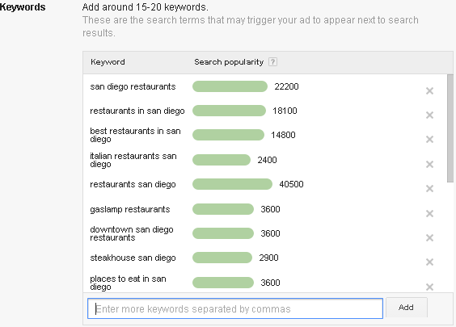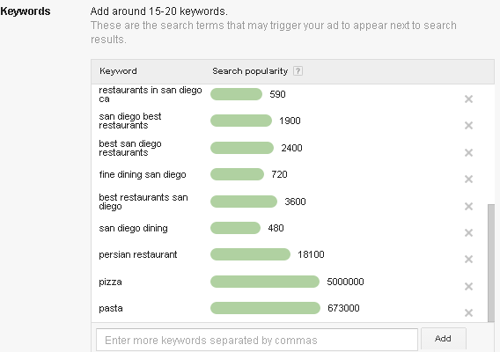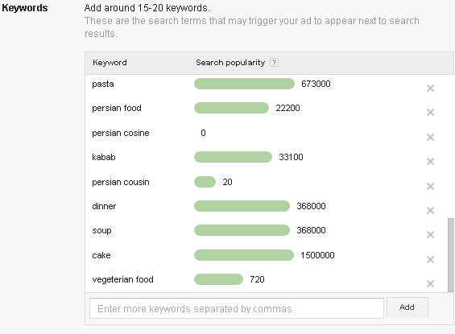

6. Three web sites I regularly visit.

Site 1: **Google News**

1. Strengths of this site? **Fast and acceptable searches.**
2. Weaknesses of this site? **news selection is biased.**
3. How friendly is this site? **It is very friendly.**

Site 2: **Yahoo news**

1. Strengths of this site? **News on the main page.**
2. Weaknesses of this site? **Is loaded with ads.**
3. How friendly is this site? **Is friendly.**

Site 3: **CNN news**

1. Strengths of this site? **Relevant news content.**
2. Weaknesses of this site? **Poor main page layout.**
3. How friendly is this site? **Is friendly.**

Common characteristics that good web sites share?

**Consistency content, easy to navigate, frequents updates, colorful.**

Characteristics that can be applied to my efforts are: **all of the above characteristics**

7.Consider the three scenarios below and discuss how you would provide clarity and quality to each of the audience groups that are visiting the “Explore California” website (shown in the lectures) for information.

1. A resident of California planning a one-day backpacking trip near her home.

**Links to California hiking trials and maps.**

1. A father in Massachusetts planning a two-week vacation to California for a family of four.  
   **links to locations to theme parks and family events.**
2. An international visitor from Japan interested in cycling across the state.   
   **Present information in Japanese as well as English’**

**Considerer Japanese culture when displaying information. Provide links California Japanese Restaurants.**

8. Search one keyword using a search engine of your choice, and then identify the website that appears first in the organic listing and the website the appears 20th in the organic listing. Create two columns and add these URLs to the top of each one. In each column list as many characteristics about each website as you easily identify.

### [Best Persian restaurant in San Diego, CA - Yelp](https://www.yelp.com/search?find_desc=Persian+Restaurant&find_loc=San+Diego%2C+CA)

<https://www.yelp.com/search?find_desc=Persian+Restaurant&find_loc=San+Diego%2C+CA>

### [Kasra Persian & Afghan Cuisine](https://www.google.com/url?sa=t&rct=j&q=&esrc=s&source=web&cd=19&cad=rja&uact=8&ved=0ahUKEwjfxcvQ7dLOAhVN8mMKHfgxCoM4ChAWCE8wCA&url=http%3A%2F%2Fkasracuisine.com%2F&usg=AFQjCNEek5s3EvY1cyxUvXX7rACguwQhSA&sig2=TZgXuEOyF6TcJNTgxJlpIw&bvm=bv.129759880,d.cGc)

<https://www.google.com/url?sa=t&rct=j&q=&esrc=s&source=web&cd=19&cad=rja&uact=8&ved=0ahUKEwjfxcvQ7dLOAhVN8mMKHfgxCoM4ChAWCE8wCA&url=http%3A%2F%2Fkasracuisine.com%2F&usg=AFQjCNEek5s3EvY1cyxUvXX7rACguwQhSA&sig2=TZgXuEOyF6TcJNTgxJlpIw&bvm=bv.129759880,d.cGc>

Keyword used in my search: Perssian r**estaurant**

|  |  |
| --- | --- |
| [[Best Persian restaurant in San Diego, CA - Yelp](https://www.yelp.com/search?find_desc=Persian+Restaurant&find_loc=San+Diego%2C+CA)](https://www.yelp.com/search?find_desc=Persian+Restaurant&find_loc=San+Diego%2C+CA) | [[Kasra Persian & Afghan Cuisine](https://www.google.com/url?sa=t&rct=j&q=&esrc=s&source=web&cd=19&cad=rja&uact=8&ved=0ahUKEwjfxcvQ7dLOAhVN8mMKHfgxCoM4ChAWCE8wCA&url=http%3A%2F%2Fkasracuisine.com%2F&usg=AFQjCNEek5s3EvY1cyxUvXX7rACguwQhSA&sig2=TZgXuEOyF6TcJNTgxJlpIw&bvm=bv.129759880,d.cGc)](https://www.google.com/url?sa=t&rct=j&q=&esrc=s&source=web&cd=19&cad=rja&uact=8&ved=0ahUKEwjfxcvQ7dLOAhVN8mMKHfgxCoM4ChAWCE8wCA&url=http%3A%2F%2Fkasracuisine.com%2F&usg=AFQjCNEek5s3EvY1cyxUvXX7rACguwQhSA&sig2=TZgXuEOyF6TcJNTgxJlpIw&bvm=bv.129759880,d.cGc) |
| Nice layout | Kasra persian restaurant highlighted |
| Restaurant listings | Very colorful |
| Nice images | Beautiful scenery |

9.Search engines often discover new content by reading a website’s XML sitemap (a specially formatted listing of the site’s pages). For this exercise, take a moment to learn more about the specific syntax and how to create XML sitemaps by visiting – <http://www.sitemaps.org>

Now create a sitemap.xml file for your website.

<?xml version="1.0" encoding="UTF-8"?>

<[urlset](http://www.sitemaps.org/protocol.html#urlsetdef) xmlns="http://www.reliantlimo.com/schemas/sitemap/0.9">

   <[url](http://www.sitemaps.org/protocol.html#urldef)>

      <[loc](http://www.sitemaps.org/protocol.html#locdef)>http://www.example.com/</loc>

      <[lastmod](http://www.sitemaps.org/protocol.html#lastmoddef)>2005-01-01</lastmod>

      <[changefreq](http://www.sitemaps.org/protocol.html#changefreqdef)>monthly</changefreq>

      <[priority](http://www.sitemaps.org/protocol.html#prioritydef)>0.8</priority>

   </url>

   <[url](http://www.sitemaps.org/protocol.html#urldef)>

      <[loc](http://www.sitemaps.org/protocol.html#locdef)>http://www.example.com/catalog?item=12&amp;desc=vacation_hawaii</loc>

      <[changefreq](http://www.sitemaps.org/protocol.html#changefreqdef)>weekly</changefreq>

   </url>

   <[url](http://www.sitemaps.org/protocol.html#urldef)>

      <[loc](http://www.sitemaps.org/protocol.html#locdef)>http://www.example.com/catalog?item=73&amp;desc=vacation_new_zealand</loc>

      <[lastmod](http://www.sitemaps.org/protocol.html#lastmoddef)>2004-12-23</lastmod>

      <[changefreq](http://www.sitemaps.org/protocol.html#changefreqdef)>weekly</changefreq>

   </url>

   <[url](http://www.sitemaps.org/protocol.html#urldef)>

      <[loc](http://www.sitemaps.org/protocol.html#locdef)>http://www.example.com/catalog?item=74&amp;desc=vacation_newfoundland</loc>

      <[lastmod](http://www.sitemaps.org/protocol.html#lastmoddef)>2004-12-23T18:00:15+00:00</lastmod>

      <[priority](http://www.sitemaps.org/protocol.html#prioritydef)>0.3</priority>

   </url>

   <[url](http://www.sitemaps.org/protocol.html#urldef)>

      <[loc](http://www.sitemaps.org/protocol.html#locdef)>http://www.example.com/catalog?item=83&amp;desc=vacation_usa</loc>

      <[lastmod](http://www.sitemaps.org/protocol.html#lastmoddef)>2004-11-23</lastmod>

   </url>

</urlset>

10. The robots.txt file allows you to control how search engines crawl through and index your website. In this step, take a moment to learn more about creating robots.txt rules by visiting: <http://www.robotstxt.org>

Now, create a robots.txt file for your website.

**User-agent: \***

**Disallow: /cgi-bin/**

**Disallow: /tmp/**

**Disallow: /~joe/**

11. When people post and share links to your content via social media or indicate its quality by clicking a button, search engines notice. Translation: Social media influences SEO. Considering this, make a list of media tools you use, sharing your thoughts about each.

Media tools used:

Media Tool 1: **Twitter**

Media Tool 2: **Facebook**

Thoughts on each:

**Twitter is a great tool for reaching same minded people and fast communications with friends and business**.

**Facebook is good place to find new friends and share ideas about different issues.**

Explain your experiences with each and report what impact it has made on your organization.

My experience with Facebook and Twitter has been OK. I found most of my friends there. Since I don’t have any business, I can’t measure the influence on it at this time.

12.Consider additional ways you can track and evaluate the effectiveness of your SEO efforts beyond common Keyword Performance Indicators (KPI).

Are there terms and strategies specific to your industry or market segment?

1. Search Engine Share of Referring Visits.
2. Search Engine Referrals.
3. Visits Referred by specific Search Engine Terms and Phrases.
4. Conversion Rate by Search Query Term/Phrase.
5. Number of pages receiving at least one visit from search engines.

13. Customer product reviews and testimonials and social media sharing may improve your SEO. Knowing this, consider one ecommerce website you use, noting if it includes the functionality suggested above.

**I use YouTube, and Ebay**

If it does, which functionality?

**It has a ratings system.**

If it does not, which features would work best on it?

**It has reviews system.**

1. Consider your experiences searching for local businesses and share insights into those you’ve found frequently, as well as those listings that have been most helpful.

Listing I found most helpful: **Persian restaurants**

Also, share your experiences reviewing a business using Google+ Local, Yahoo! Local, Yelp, City Search, or other similar websites.

Business review: **Darband Fifth Avenue Grill, San Diego**

**5 Stars**

**“**I travel a lot and through the years, I have developed a ritual of visiting the notorious Persian restaurants. I'll cut to the chase... I had a pleasant experience at Darband. The owner is very passionate about what he does and he is definitely a people person. The restaurant is very laid back and informal. The business model is very similar to that of Moby Dick's at DC, if you have ever been there. You order your food and someone brings it to your table and you pay at the counter. We ordered the Darband Special, which is a mix of koobideh, shish kabab and jooje. The kababs were fresh and tender and the rice was fluffy and delicious. I absolutely recommend this restaurant.**.” in 756 reviews**

**“**"I really wanted to give this place a five star review. We came here on a Saturday night when it was quite busy. We had reservations so we were seated immediately. What really confused us throughout the…".**” in 105 reviews**

**“**"So I was sitting with a buddy of mine and he was shocked to hear that I hadn't tried the pizza yet. So he ordered one, we were both hungry and watching football. It was delivered and I was intrigued when I…"**.” in 104 reviews**

Likewise, has your business ever been reviewed?

**No, because I don’t have one yet.**

15. Is your website mobile friendly?

**Yes**

If not, what steps could you take to improve the performance of your website on mobile devices (tablet, phone)?

**N/A**

Also, consider the three types of configurations for improving your mobile web content.

## Responsive,

* Sites that use responsive web design, i.e. sites that serve all devices on the same set of URLs, with each URL serving the same HTML to all devices and using just CSS to change how the page is rendered on the device. This is Google’s recommended configuration.

## Dynamic,

* Sites that dynamically serve all devices on the same set of URLs, but each URL serves different HTML (and CSS) depending on whether the user agent is a desktop or a mobile device.

## Mobile URL

* Sites that have separate mobile and desktop URLs.

How can you apply these to get the most out of your site?

The goal is to first determine if my site will be showing the same or different content by device. Does the intent of the visitor differ by device? If someone is visiting my site from a desktop versus a mobile device, what is each type of user trying to accomplish?

If my visitors are trying to do the same thing while on a desktop as well as a mobile device, I will serve the same content, so responsive would be my choice. People maybe coming to my site to read content, no matter the device. My site will style the content slightly different for mobile, but it’s essentially the same content.

- Assignment 647 in Progress.